**A System for Medical Assistance by Text processing**

By

**Mahin Rashid Chowdhury**

Roll: 1907021

&

**Jobair Al Nahian**

Roll: 1907071



**Supervisor:**

Dr. K. M. Azharul Hasan

Professor

Dept. of Computer Science and Engineering Signature

Khulna University of Engineering & Technology

**Department of Computer Science and Engineering**

**Khulna University of Engineering & Technology**

**Khulna 9203, Bangladesh**

**November 2023**

**Acknowledgements**

First and foremost, I must be grateful to and wish to acknowledge my insightful indebtedness to Dr. K. M. Azharul Hasan, Professor of the Department of Computer Science and Engineering and the supervisor of the project. His unfathomable knowledge in this field influenced me to carry out this project up to this point. His endless endurance, scholarly guidance, continual encouragement, constant and lively supervision, constructive criticism, and priceless suggestions made it possible to come up to this phase. Without his inspiring, enthusiasm, and encouragement, this work could not have been completed. Last, but by no means least, I thank Allah for the talents and abilities I was given that made it possible to undertake this project.

Next, We want to express my gratitude to all of my class teachers who have shared their knowledge with us, which has aided us in completing our project. Also, a big thanks to my classmates for sharing their knowledge and always giving support, which helped us finish this project.

**Authors**

**Abstract**

In the medical world, it's often tough to get quick and reliable information about symptoms, health conditions, and what to do next. Many people can't easily reach healthcare professionals, and there's a growing number of health questions. This situation calls for a smart solution to make sure everyone can access the information they need.

Fixing the problem we talked about would be really good for both doctors and regular people. If everyone can easily find accurate health information, it helps people make better choices about their health. This could also mean fewer trips to the emergency room for things that aren't super urgent. And overall, it helps everyone understand more about staying healthy.

The idea is to create a smart computer assistant known as a chatbot, with expertise in medical information. This chatbot uses advanced language skills and a database of medical knowledge. It's designed to help people by giving them accurate and timely information about symptoms, conditions, and what steps to take. The chatbot's design aligns with the objective of addressing the broader problem of limited accessibility to reliable medical information. make it more simple.

For health-related queries, the chatbot is like having a health assistant. Its vast knowledge base contains current and reliable medical information, so users can rely on its advice. Speaking with the chatbot enables people to make informed decisions and have a better understanding of their health. In addition, a lot of people might receive the assistance they require because the chatbot is made to be simple to use by anyone.

**Contents**

|  |  |  |
| --- | --- | --- |
|  |  | **Page** |
| Acknowledgement |  | ii |
| Abstract |  | iii |
| Contents |  | iv |
| List of Tables |  | vi |
| List of Figures |  | vii |

|  |  |  |
| --- | --- | --- |
| **1** | **Introduction** | 1 |
|  | 1.1 Background / Problem statement | 1 |
|  | 1.2 Objectives | 3 |
|  | 1.3 Scopes | 3 |
|  | 1.4 *Unfamiliarity of the problem/topic/solution* | 4 |
|  | 1.5 *Project planning* (Hint: Write about the work plan using RACI matrix/Gantt Chart etc.) | 6 |
|  | 1.6 …………………. | 6 |
| **2** | **Related Work** (Optional Section) | 7 |
|  | 2.1 Existing solutions | 7 |
|  | 2.2 Limitation in existing solutions (Hint: Write a summary using table and prove that the problem idea is a new one and not acquired directly from any existing sources) | 8 |
|  | 2.3 ……………………. | 10 |
| **3** | **System Design** | 14 |
|  | 3.1 Analysis of the system (Hint: Include DFD, use case diagram, etc.) | 14 |
|  | 3.2 System architecture (Hint: Include class diagram, detailed architecture of your system, etc.) | 14 |
|  | 3.3 *Tools / Platform used* (Hint: Reason for choosing platform, etc.) | 15 |
|  | 3.3.1 Google Colab | 16 |
|  | 3.3.2 python | 17 |
|  | 3.4 …………………… | 19 |
| **4** | **Project Implementation** | 22 |
|  | 4.1 System implementation (Also include User Manual considering Front End) | 22 |
|  | 4.2 *Morality or Ethical issues* (Hint: Proper citations or acknowledgement and plagiarism) | 24 |
|  | 4.3 *Socio-economic impact and sustainability* (Hint: Write down the impact of the project on societal, health, safety, legal, and cultural issues also the impact of project on the environment and sustainability) | 25 |
|  | 4.4 *Financial analyses and budget* (Overall budget planning or Component / Software Budget planning. It can be written in Appendices also.) | 26 |
|  | 4.5 ………. | 27 |
| **5** | **Conclusions** | 28 |
|  | 5.1 Conclusion and challenges faced | 28 |
|  | 5.2 Future work | 29 |
|  | 5.3 …………. | 30 |
|  |  |  |
|  | **References** | 31 |
|  | Appendices (If any) |  |

**List of Tables**

|  |  |  |
| --- | --- | --- |
| **Table No.** | **Description** | **Page** |
| 2.1 | Network construction using Physarum. | 6 |
| 3.1 | Time comparison in car, bus and bicycle. | 23 |

**List of Figures**

|  |  |  |
| --- | --- | --- |
| **Figure No.** | **Description** | **Page** |
| 3.1 | Real traffic network. | 16 |
| 4.1 | Selected Dhaka city Map. | 18 |

1. Introduction
   1. Background

In the world of health, sometimes it's hard to find the right information quickly. People have questions about symptoms, illnesses, and what to do to feel better, but they might not always have easy access to a doctor. That's where our smart friend, the ChatBot, comes in. It's here to help bridge that gap and make sure everyone can get reliable information about their health. Think of it like having a knowledgeable friend who can answer your health questions anytime, day or night. The idea is to solve the challenge of not always being able to find accurate and timely health information when you need it. This ChatBot is like a friendly guide in the world of health, ready to assist and provide trustworthy advice whenever someone has a health-related question. People may feel a little uncertain or concerned about their health in numerous circumstances, particularly if they find it difficult to get in touch with a medical practitioner. The ChatBot is intended to be a comforting and trustworthy information source. It's similar to getting a nice virtual health companion that comprehends your inquiries.

Ensuring that everyone, wherever they may be, has hassle-free access to clear and accurate health information is the challenge we're taking on. The ChatBot simplifies health information for all users by speaking your language like a human encyclopedia. People will be able to take control of their health and well-being and make knowledgeable decisions about it. The ultimate objective is to equip people with the knowledge they need to maintain their health and feel.

* 1. Objectives
* Create a Medical Chatbot System: Develop a system that can answer health questions and help people understand possible medical issues.
* Make an Easy and Friendly Interface: Design a website that's simple to use, so anyone can find the health information they need without confusion.
* Understand Questions Better: Teach the chatbot to comprehend what people say in a natural way, improving its ability to figure out possible health problems.
* Give Simple Info on Diseases: Ensure that the Chatbot shares clear and easy-to-understand details about what might be causing a health issue and what can be done about it.
* Maintain a database: The system maintains a database to store user information and past conversations. This ensures that users can easily refer back to previous responses, promoting reliability and continuity in interactions.

These objectives aim to build a Medical Chatbot that's not only good at tech stuff but also makes it easy and helpful for everyone who needs health info, using regular language.

* 1. Scope

The medical Chatbot project has a broad scope that includes a variety of elements to offer a customized and broad user experience. This is a summary of the project's scope:

* User Authentication and Profile Management: Users can log in to the website, creating individual profiles that allow for personalized interactions and secure storage of health-related data.
* Chat Interface: A user-friendly chat interface where users can communicate with the Chatbot by providing symptoms and asking health-related questions.
* Symptom Analysis: The Chatbot analyzes user-inputted symptoms to identify potential health conditions or diseases.
* Disease Information: Provides detailed information about identified diseases, including causes, symptoms, and preventive measures to enhance user awareness and understanding.
* Treatment Recommendations: Offers personalized treatment recommendations based on identified diseases, guiding users on potential courses of action or medical interventions.
* Conversation History: Saves and categorizes each user's conversation history, allowing users to review previous interactions, symptoms, and responses for ongoing health management.
* Responsive Design: Ensures a responsive design for seamless user experience across different devices, such as desktops, tablets, and mobile phones.
  1. Unfamiliarity of the problem

The unfamiliarity with the problem in the context of a medical chatbot lies in the challenge of limited accessibility to timely and accurate health information. Many individuals face difficulty obtaining quick and reliable answers about symptoms, conditions, and healthcare options. The unfamiliarity arises from the gap in easily reaching healthcare professionals and the increasing need for accessible and trustworthy health guidance. The medical chatbot aims to address this unfamiliarity by providing a user-friendly solution that offers reliable information, empowers users, and contributes to improved health literacy.

* 1. Project planning

Our plan for the medical Chatbot is like a roadmap showing how we'll turn our idea into reality. We want to solve the problem of people not easily getting health info. The plan includes features like checking symptoms, explaining diseases, and suggesting treatments. We've set a clear schedule and figured out what we need, like people and money, to make it happen. We're also thinking about possible problems and how to make sure everything works well. Our plan is like a guide, making sure we stay on track and create a helpful and easy-to-use chatbot for everyone.

1. Related Works
   1. Related works

There exists already an online android application named “Maya - It's ok to ask for help” [9]. It’s a health care app which connects users with hundreds of doctors, psychiatrists and beauticians ready to serve 24 hours a day. Here user can write questions about his problems about health and the doctors’ advice giving reply and facility to video call and can get digital prescription from doctors and there is extra facility to shop and read medical blogs.

* 1. Gap in Existing Solutions

The intelligent behavior of slime mold was first observed by Nakagaki et al. in 2000 [2]. They assume that the flow is laminar and follows the Hagen-Poiseuille equation, the flux through the tube is,

$$Q_{ij}= \frac{πr_{ij}^{4}\left(P_{i}- P_{j}\right)}{8εL_{ij}} = \frac{D_{ij}\left(P_{i}- P_{j}\right)}{L_{ij}} , \left(2.1\right)$$

here $ε$ is the viscosity of the fluid, and $D_{ij}= \frac{πr_{ij}^{4}}{8ε}$ is a measure of the conductivity of the tube. As the length $L_{ij}$ is a constant, the behavior of the network is described by the conductivities of the edges.

Here we summarize various works of network construction using Physarum inspired technique in the following Table 2.1.

1. System Design

There exist lots of challenges in some of mega cities like Dhaka such as road conditions are not good enough, cycling lanes ………………………

* 1. Analysis of the system

This research aims at extending a construction pattern for our network to Dhaka, Bangladesh's capital city. The main challenges with Dhaka city are described in followings……DFD Diagram.

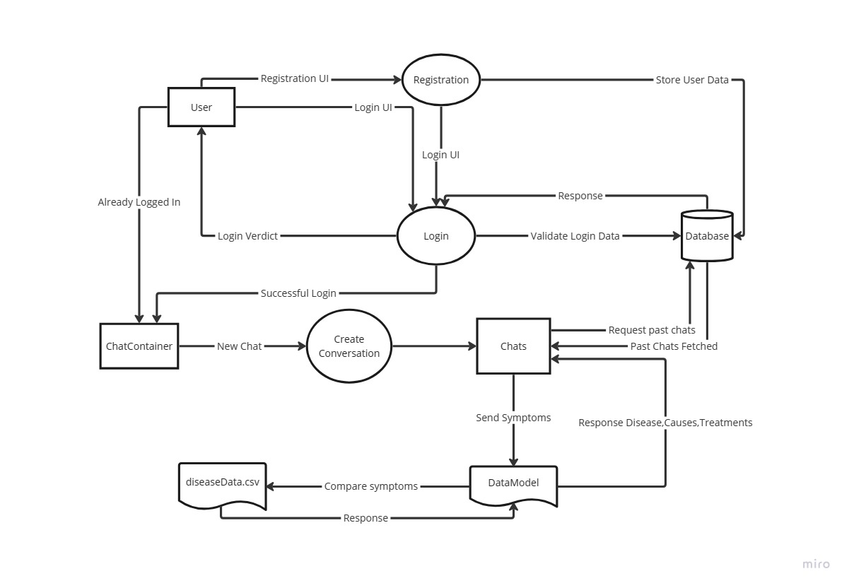

* 1. System architecture

Figure 3.1: Data flow diagram of the system with respect to a user and bot responses.

Green City also named as Eco-city or Sustainable city is a city designed with consideration

* 1. Tools used

In more ways than one, driving a bicycle has a positive impact on the environment. They are also less expensive than other forms of ………………………………………

* + 1. Android Studio

Bicycles are considered zero-emission vehicles i.e. they do not release any carbon emissions. Bicycles, as vehicles with ………………………………………

**3.4 UML Class Diagram:**

* + 1. Kotlin

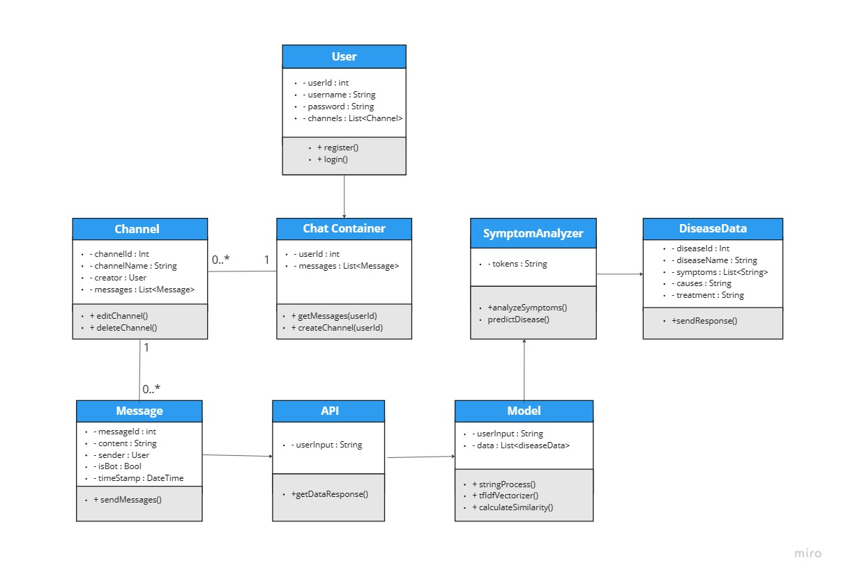

Bicycles are considered zero-emission vehicles i.e. they do not release any carbon emissions. Bicycles, as vehicles with ………………………………………

Figure 3.2: UML class diagram of the System architecture.

**3.5 Use Case Diagram:**

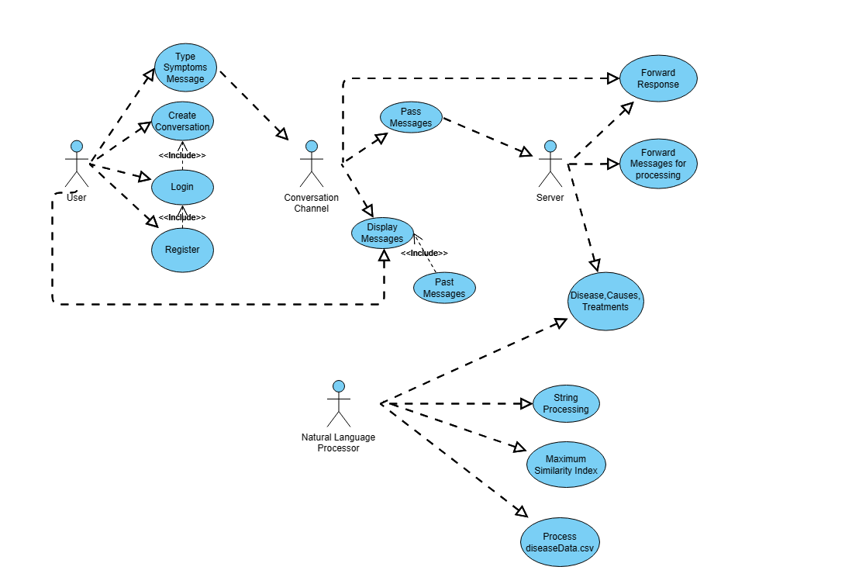

Figure 3.2: Use case diagram of the System.

**Schema Diagram :**

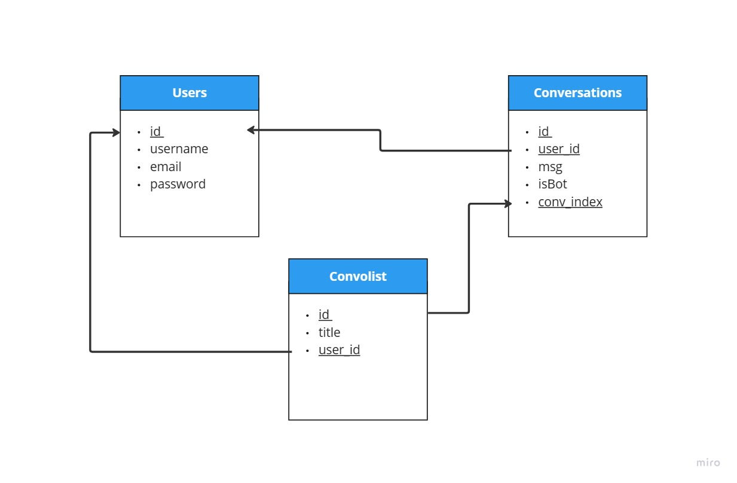

Figure 3.2: Schema diagram of the System.

1. Project Implementation

This chapter implements the……………….

* 1. System implementation

At first, a selected portion of Dhaka city is considered to construct the network using Physarum inspired technique…………….

* 1. Morality or ethical issues

At first, a selected portion of Dhaka city is considered to construct the network using Physarum inspired technique. And it can also lead to better mental health and energy by bicycling 30 minutes a day [3], [4]………………………….

* 1. Socio-economic impact and sustainability

At first, a selected portion of Dhaka city is considered to construct the network using Physarum inspired technique……………....................................

* 1. Financial analyses and budget

At first, a selected portion of Dhaka city is considered to construct the network using Physarum inspired technique……………………….

1. Conclusion

A modified Physarum-inspired model is presented in this project to address the design of the bicycle lane network…………………………………….

* 1. Conclusion and challenges faced

The network design technology inspired by Physarum is believed to have balanced costs, effectiveness, and resilience. Inside Dhaka city, an unorganized and unplanned city, we have developed an electric bicycle ……………………

* 1. Future Study

# In the future, parallel computing and the optimal model for the design of the transport network are part of our work. Furthermore, our research includes the implementation of the Physarum ……………………….

# References

[1] C. Oettmeier, K. Brix, and H.-G. Döbereiner, “Physarum polycephalum —a new take on a classic model system,” *J. Phys. D. Appl. Phys.*, vol. 50, no. 41, p. 413001, Oct. 2017, doi: 10.1088/1361-6463/aa8699.

[2] T. Nakagaki, H. Yamada, and Á. Tóth, “Maze-solving by an amoeboid organism,” *Nature*, vol. 407, no. 6803, pp. 470–470, Sep. 2000, doi: 10.1038/35035159.

[3] C. Rissel, “Health benefits of cycling,” in *Cycling Futures*, University of Adelaide Press, 2015, pp. 43–62. doi: 10.20851/cycling-futures-03.

[4] P. Oja *et al.*, “Health benefits of cycling: a systematic review,” *Scand. J. Med. Sci. Sports*, vol. 21, no. 4, pp. 496–509, Aug. 2011, doi: 10.1111/j.1600-0838.2011.01299.x.

[5] “Number of registered Vehicles in Dhaka Metro,” Dhaka, 2020. [Online]. Available: http://www.brta.gov.bd/site/page/4632772e-f586-46f5-a0ac-0fcbe2ba12ae/ঢাকা-মেট্টোতে-মোটরযান-নিবন্ধনের-সংখ্যা

[6] A. Tero *et al.*, “Rules for Biologically Inspired Adaptive Network Design,” *Science (80-. ).*, vol. 327, no. 5964, pp. 439–442, Jan. 2010, doi: 10.1126/science.1177894.

[7] A. Adamatzky and R. Alonso-Sanz, “Rebuilding Iberian motorways with slime mould,” *Biosystems*, vol. 105, no. 1, pp. 89–100, Jul. 2011, doi: 10.1016/j.biosystems.2011.03.007.

[8] A. Adamatzky, G. J. Martínez, S. V. Chapa-Vergara, R. Asomoza-Palacio, and C. R. Stephens, “Approximating Mexican highways with slime mould,” *Nat. Comput.*, 2011, doi: 10.1007/s11047-011-9255-z.

[9] https://play.google.com/store/apps/details?id=com.maya.mayaapaapp&hl=en&gl=US

**N.B.** This is the preferable format for Report writing. The subsections written in italic forms (i.e., 1.4, 1.5, 4.2, 4.3, 4.4) are fixed. However, the Supervisor can extend the sections/points of the report (if necessary).